Jane’s Mandarin Tutor Studio
GCSE Mandarin · Free resources
https://janesmandarintutor.co.uk/

Topic 4: Customs and festivals
Theme 1: Identity and culture · Festivals and customs in Chinese-speaking countries and communities

Key vocabulary
Chinese | Pinyin | English
Festivals
节日 | jiérì | festival
春节 / 中国新年 | chūnjié / zhōngguó xīnnián | Spring Festival / Chinese New Year
新年 | xīnnián | new year
中秋节 | zhōngqiūjié | Mid-Autumn Festival
端午节 | duānwǔjié | Dragon Boat Festival
圣诞节 | shèngdàn jié | Christmas
复活节 | fùhuójié | Easter
过生日 | guò shēngrì | to celebrate a birthday
Food and customs
饺子 | jiǎozi | dumpling
月饼 | yuèbǐng | mooncake
粽子 | zòngzi | sticky rice dumpling
红包 | hóngbāo | red envelope (lucky money)
舞龙 | wǔlóng | dragon dance
舞狮 | wǔshī | lion dance
鞭炮 | biānpào | firecrackers
放 | fàng | to set off (firecrackers)
灯笼 | dēnglóng | lantern
龙舟 | lóngzhōu | dragon boat
Gifts and guests
礼物 | lǐwù | gift
送礼物 | sòng lǐwù | to give gifts
收 | shōu | to receive
感谢 | gǎnxiè | thankful, gratitude, to thank
请 | qǐng | to invite
邀请 | yāoqǐng | to invite
客人 | kèren | guest

Grammar and complex structures for this topic
Use these in your speaking and writing. The full list is in the separate grammar document.
Structure | Meaning | Example for this topic
……的时候 | when … | 过春节的时候，中国人吃饺子。  At the Spring Festival, Chinese people eat dumplings.
跟……一样 / 不一样 | the same as / different from … | 春节跟圣诞节不一样。  The Spring Festival is different from Christmas.
一边……一边…… | doing two things at the same time | 我们一边吃饭一边看电视。  We watch TV while eating.
虽然……但是…… | although … | 虽然我不是中国人，但是我很喜欢过春节。  Although I am not Chinese, I love celebrating the Spring Festival.
最重要的是…… | the most important thing is … | 过节的时候，最重要的是全家在一起。  At festival time, the most important thing is that the whole family is together.
如果……就…… | if … then … | 如果有机会，我就去中国过春节。  If I get the chance, I will spend the Spring Festival in China.

Speaking questions and model answers
Photo card: a photo of a lion dance in a street with red lanterns.
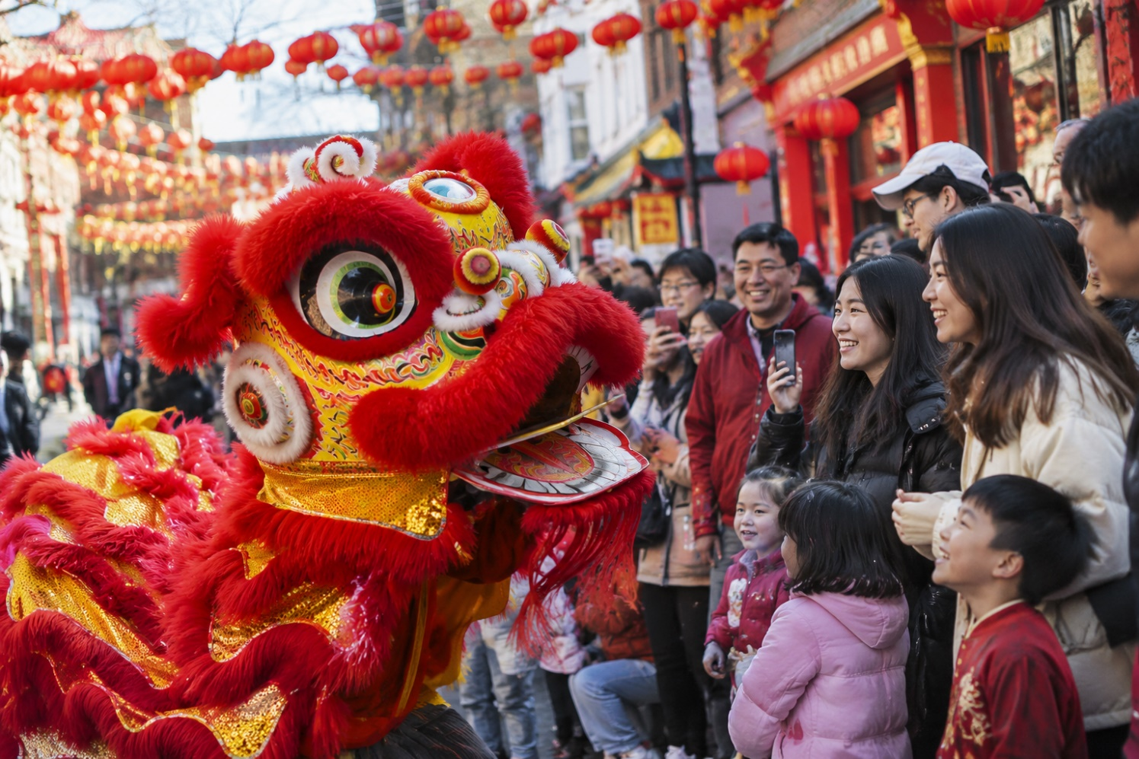

Q1 · Photo card
Question: 照片里有什么？ What is in the photo?
Model answer (Higher): 照片里有很多人在看舞狮。大街上有很多红色的灯笼。我觉得这可能是春节，因为舞狮和红灯笼都是春节的东西。大家看起来很高兴，因为他们都在笑。
English: In the photo lots of people are watching a lion dance. There are lots of red lanterns in the street. I think it might be the Spring Festival, because lion dances and red lanterns are part of the Spring Festival. Everyone looks happy, because they are all smiling.
Exam tip: Use 我觉得…… to say what you think is happening, and back it up with 因为 and details you can see (舞狮, 红灯笼).

Q2 · General conversation
Question: 你最喜欢什么节日？为什么？ What is your favourite festival? Why?
Model answer (Higher): 我最喜欢的节日是春节，因为不但可以吃饺子、看舞龙舞狮，而且孩子们可以收红包。虽然我不是中国人，但是我们学校每年都过春节。
English: My favourite festival is the Spring Festival, because not only can you eat dumplings and watch dragon and lion dances, but children also get red envelopes. Although I am not Chinese, our school celebrates the Spring Festival every year.
Exam tip: Complex structures: 不但……而且……, 虽然……但是……, 最喜欢的……是……. Vocabulary: 舞龙, 舞狮, 红包.

Q3 · General conversation
Question: 去年圣诞节你做了什么？ What did you do last Christmas?
Model answer (Higher): 去年圣诞节我们全家去了奶奶家。我们一起吃了火鸡，然后送礼物。我给奶奶送了一个蛋糕，她非常高兴。晚上我们一边吃饭一边看电视。今年圣诞节我们打算去叔叔家。
English: Last Christmas the whole family went to my grandma’s. We had turkey together and then gave presents. I gave my grandma a cake and she was very happy. In the evening we watched TV while we ate. This Christmas we plan to go to my uncle’s.
Exam tip: Complex structures: 一边……一边……, ……然后……. Time frames: past (去了, 吃了, 送了) and future (今年圣诞节我们打算……).

Q4 · General conversation
Question: 你觉得春节和圣诞节有什么不一样？ How is the Spring Festival different from Christmas?
Model answer (Higher): 春节和圣诞节都是很重要的节日，大家都和家人一起吃饭。但是，过春节的时候，中国人吃饺子，给孩子红包；过圣诞节的时候，英国人吃火鸡，送礼物。去年我第一次和中国朋友一起过春节，觉得很有意思。明年我也想和他们一起过春节。
English: The Spring Festival and Christmas are both important festivals, when everyone eats with their family. But at the Spring Festival Chinese people eat dumplings and give children red envelopes; at Christmas British people eat turkey and give presents. Last year I celebrated the Spring Festival with Chinese friends for the first time, which was very interesting. Next year I also want to celebrate the Spring Festival with them.
Exam tip: Complex structures: ……的时候, comparing with 都 and 但是. Time frames: past (去年我第一次……) and future (明年我也想……).

Q5 · General conversation
Question: 将来你想去中国过节吗？ Would you like to celebrate a festival in China in the future?
Model answer (Higher): 我以前在电视上看过春节。如果有机会，我就去中国过春节，因为我想看舞龙，也想放鞭炮。我还想和中国朋友一起包饺子，因为包饺子很好玩儿。
English: I have seen the Spring Festival on TV before. If I have the chance, I will go to China for the Spring Festival, because I want to see a dragon dance and let off firecrackers. I would also like to make dumplings with Chinese friends, because it is great fun.
Exam tip: Complex structures: 如果……就……, verb + 过 (看过). Time frames: past (我以前在电视上看过……) and future (如果有机会，我就去中国……).

More general conversation questions
- 你怎么庆祝你的生日？ How do you celebrate your birthday?
- 中秋节的时候，中国人会做什么？ What do Chinese people do at the Mid-Autumn Festival?
- 去年你过生日的时候收到了什么礼物？ What presents did you get for your birthday last year?
- 明年过生日的时候，你想做什么？ What would you like to do for your birthday next year?
- 你觉得送礼物重要吗？为什么？ Is giving presents important? Why?
- 英国有什么有名的节日？ What famous festivals are there in the UK?

Need a tutor for GCSE Mandarin preparation or catching up? Visit: https://janesmandarintutor.co.uk/
Enquiries accepted from adult learners and parents only.

