Jane’s Mandarin Tutor Studio
GCSE Mandarin · Free resources
https://janesmandarintutor.co.uk/

Topic 11: Education post-16
Theme 3: Current and future study and employment · Sixth form, college, university and other options

Key vocabulary
Chinese | Pinyin | English
After GCSEs
大学 | dàxué | university
大学生 | dàxuéshēng | university student
毕业 | bìyè | to graduate
工作 | gōngzuò | to work; job
社会实践 | shèhuì shíjiàn | work experience
申请 | shēnqǐng | to apply for, application
信 | xìn | letter
学期 | xuéqī | term
高考 | gāokǎo | university entrance exam (in China)
计划 | jìhuà | plan; to plan
打算 | dǎsuàn | to plan; plan
将来 | jiānglái | future/in the future
Work and pressure
压力 | yālì | pressure
兼职 | jiānzhí | part-time job
义工 | yìgōng | volunteer; voluntary work
挣钱 / 赚钱 | zhèngqián / zhuànqián | to earn money

Grammar and complex structures for this topic
Use these in your speaking and writing. The full list is in the separate grammar document.
Structure | Meaning | Example for this topic
……以后，我打算…… | after …, I plan to … | GCSE考试以后，我打算学数学和中文。  After my GCSEs I plan to study maths and Chinese.
与其……不如…… | rather than … it is better to … | 与其马上上大学，不如先工作一年。  Rather than going straight to university, it’s better to work for a year first.
一方面……另一方面…… | on the one hand … on the other hand … | 一方面上大学很贵，另一方面可以找到好工作。  On the one hand university is expensive; on the other hand you can find a good job.
为了…… | in order to … | 为了挣钱，暑假的时候我找了一个兼职。  To earn money, I found a part-time job in the summer holidays.
虽然……但是…… | although … | 虽然有点儿累，但是我学到了很多东西。  Although it was a bit tiring, I learned a lot.

Speaking questions and model answers
Photo card: a photo of a family having their photo taken at a graduation, with many graduates behind them.
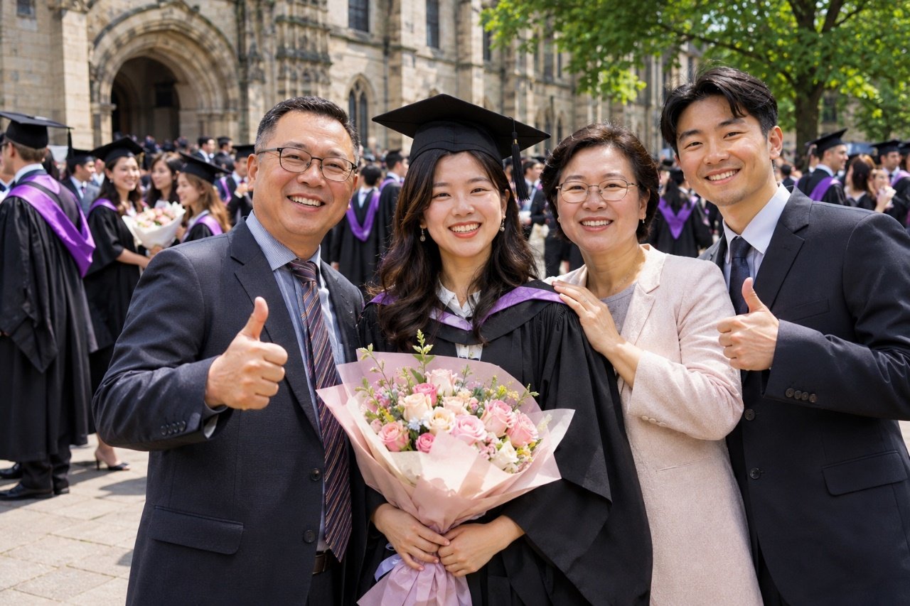

Q1 · Photo card
Question: 照片里有什么？ What is in the photo?
Model answer (Higher): 照片里有很多人。前边有四个人在照相，他们看起来都很高兴，因为他们都在笑。我觉得他们今天大学毕业了，因为后边很多人都穿着一样的毕业服。
English: In the photo there are lots of people. At the front, four people are having their photo taken; they all look very happy, because they are all smiling. I think they graduated from university today, because lots of people at the back are all wearing the same graduation gowns.
Exam tip: Describe only what you can see. Use position words (前边 / 后边) to organise your description. Complex structures: 在 + verb (四个人在照相), 看起来…… (他们看起来都很高兴), verb + 着 (穿着一样的毕业服), and 我觉得……，因为…… to give a reason for each guess.

Q2 · General conversation
Question: GCSE考试以后你打算做什么？ What do you plan to do after your GCSEs?
Model answer (Higher): 上个月我参观了一个学校，那里的老师很友好。GCSE考试以后，我打算在那个学校学数学、化学和中文，因为我将来想做医生。暑假的时候，我也打算找一个兼职，因为我想挣钱。
English: Last month I visited a school, and the teachers there were very friendly. After my GCSEs, I plan to study maths, chemistry and Chinese at that school, because I want to be a doctor. In the summer holidays I also plan to find a part-time job, because I want to earn money.
Exam tip: Complex structures: ……以后 (GCSE考试以后), ……的时候 (暑假的时候), ……，因为…… to give a reason. Time frames: past (上个月我参观了……) and future (我打算……). Vocabulary: 兼职, 挣钱 / 赚钱.

Q3 · General conversation
Question: 你想上大学吗？为什么？ Do you want to go to university? Why?
Model answer (Higher): 我想上大学，因为上大学以后可以找到更好的工作。我哥哥去年上了大学，他说大学生活又忙又有意思。不过上大学很贵，所以我可能先工作一年。
English: I want to go to university, because after university you can find a better job. My brother started university last year, and he says university life is both busy and interesting. But university is expensive, so I might work for a year first.
Exam tip: Complex structures: 又……又……, ……，所以……, ……以后. Time frames: past (我哥哥去年上了大学) and future (我可能先工作一年).

Q4 · General conversation
Question: 你做过社会实践吗？ Have you done work experience?
Model answer (Higher): 我做过社会实践。去年夏天我在一个公司工作了两个星期。我每天帮助同事，还给别人打电话。虽然有点儿累，但是我学到了很多东西。将来我也想在公司工作。
English: Yes, I have. Last summer I worked at a company for two weeks. Every day I helped my colleagues and made phone calls to other people. Although it was a bit tiring, I learned a lot. In the future I would also like to work for a company.
Exam tip: Complex structures: 虽然……但是……, verb + 过 (做过), duration (工作了两个星期). Time frames: past (去年夏天……) and future (将来我想……).

Q5 · General conversation
Question: 你觉得考试的压力大吗？ Do you think exam pressure is high?
Model answer (Higher): 我觉得考试的压力很大。上次考试以前，我每天学习到晚上十一点，睡觉睡得很少。因为压力很大，所以现在每个周末我都去跑步。考试以后，我打算和朋友去海边玩。
English: I think exam pressure is very high. Before the last exams I studied until 11pm every day and slept very little. Because the pressure is so high, I now go running every weekend. After the exams I plan to go to the seaside with my friends.
Exam tip: Complex structures: 因为……，所以…… (因为压力很大，所以……), ……以前 / ……以后, verb + 得 (睡觉睡得很少), 每……都…… (每个周末我都去跑步). Time frames: past (上次考试以前……) and future (考试以后，我打算……).

More general conversation questions
- 你想去中国上大学吗？ Would you like to go to university in China?
- 你想有间隔年吗？为什么？ Would you like a gap year? Why?
- 如果你有间隔年，你会做什么？ If you had a gap year, what would you do?
- 去年暑假你做了什么？明年暑假你想做什么？ What did you do last summer holiday? What would you like to do next summer holiday?
- 你参观过大学吗？你觉得怎么样？ Have you visited a university? What did you think?
- 你觉得中国的高考和英国的考试一样吗？ Is China’s university entrance exam the same as British exams?

Need a tutor for GCSE Mandarin preparation or catching up? Visit: https://janesmandarintutor.co.uk/
Enquiries accepted from adult learners and parents only.

