Jane’s Mandarin Tutor Studio
GCSE Mandarin · Free resources
https://janesmandarintutor.co.uk/

Topic 3: Free-time activities
Theme 1: Identity and culture · Music; cinema and TV; food and eating out; sport

Key vocabulary
Chinese | Pinyin | English
Sport
运动 | yùndòng | sport
做运动 | zuò yùndòng | to do sport
锻炼 | duànliàn | to work out
踢足球 | tī zúqiú | to play football
打篮球 | dǎ lán qiú | to play basketball
打羽毛球 | dǎ yǔmáoqiú | to play badminton
打乒乓球 | dǎ pīng pāng qiú | to play table tennis
打网球 | dǎ wǎng qiú | to play tennis
打球 | dǎqiú | to play ball games
打太极拳 | dǎ tàijíquán | to do tai chi
跑步 | pǎobù | to run
游泳 | yóuyǒng | to swim
爬山 | páshān | to climb mountains, to go hiking
钓鱼 | diàoyú | to go fishing
散步 | sànbù | to go for a walk
玩滑板 | wán huábǎn | to skateboard
去健身房 | qù jiànshēnfáng | to go to the gym
练体操 | liàn tǐcāo | to practise gymnastics
滑雪 | huáxuě | to ski
滑冰 | huábīng | to ice skate
Competitions
比赛 | bǐsài | competition
队员 | duìyuán | team member
参加 | cānjiā | to take part in
得奖牌 | dé jiǎng pái | to win a medal
成功 | chénggōng | to succeed
Music and the arts
听音乐 | tīng yīnyuè | to listen to music
唱歌 | chànggē | to sing
跳舞 | tiàowǔ | to dance
流行歌曲 | liúxíng gēqǔ | pop song
弹吉他 | tán jítā | to play the guitar
弹钢琴 | tán gāngqín | to play the piano
乐器 | yuèqì | musical instrument
演出 | yǎnchū | to perform
表演 | biǎoyǎn | to perform; performance
画画儿 | huà huàr | to draw, to paint
看京剧 | kàn jīngjù | to watch Beijing opera
Cinema, TV and reading
看电视 | kàn diànshì | to watch TV
看电影 | kàn diànyǐng | to watch a film
去电影院 | qù diànyǐngyuàn | to go to the cinema
电视节目 | diànshì jiémù | TV programme
电视剧 | diànshìjù | TV drama
动画片 | dòng huà piàn | cartoon
新闻 | xīnwén | news
赛马 | sàimǎ | horse racing
赛车 | sàichē | car racing
名人 | míngrén | celebrity
影迷 | yǐngmí | film fan
杂志 | zázhì | magazine
报纸 | bàozhǐ | newspaper
书 | shū | book
看书 | kànshū | to read
看小说 | kàn xiǎoshuō | to read a novel
写日记 | xiě rìjì | to write a diary
Going out
爱好 | àihào | hobby
有空 | yǒukòng | to have free time
交朋友 | jiāo péngyou | to make friends
请 | qǐng | to invite
买东西 | mǎi dōngxi | to go shopping
参观博物馆 | cānguān bówùguǎn | to visit a museum
购物中心 | gòuwùzhōngxīn | shopping centre
花钱 | huāqián | to spend money
买票 | mǎipiào | to buy a ticket
遛狗 | liùgǒu | to walk a dog
照相 / 拍照 | zhàoxiàng / pāizhào | to take a photo
照片 | zhàopiàn | photograph
Food
米饭 | mǐfàn | rice
饭 | fàn | meal; cooked rice
面条 | miàntiáo | noodles
面包 | miànbāo | bread
饺子 | jiǎozi | dumpling
包子 | bāozi | steamed stuffed bun
炒饭 | chǎofàn | fried rice
炒面 | chǎomiàn | fried noodles
点心 | diǎnxīn | dim sum, snacks
肉 | ròu | meat
牛肉 | niúròu | beef
猪肉 | zhūròu | pork
鸡肉 | jīròu | chicken
鸭肉 | yāròu | duck meat
羊肉 | yángròu | lamb/mutton
鱼 | yú | fish
海鲜 | hǎixiān | seafood
鸡蛋 | jīdàn | egg
菜 | cài | dish; vegetables
蔬菜 / 青菜 | shūcài / qīngcài | vegetable
白菜 | báicài | cabbage
西红柿 | xī hóng shì | tomato
汤 | tāng | soup
蛋糕 | dàngāo | cake
巧克力 | qiǎo kè lì | chocolate
冰淇淋 | bīng qí lí n | ice cream
比萨饼 | bǐ sà bǐng | pizza
烤 | kǎo | to roast
Fruit
水果 | shuǐguǒ | fruit
苹果 | píngguǒ | apple
橙子 | chéngzi | orange
香蕉 | xiāngjiāo | banana
西瓜 | xīguā | watermelon
葡萄 | pútáo | grapes
草莓 | cǎoméi | strawberry
Drinks
茶 | chá | tea
咖啡 | kāfēi | coffee
牛奶 | niúnǎi | milk
水 | shuǐ | water
汽水 | qìshuǐ | fizzy drink
果汁 | guǒzhī | fruit juice
酒 | jiǔ | alcohol
Meals and eating out
早饭 | zǎofàn | breakfast
午饭 | wǔfàn | lunch
晚饭 | wǎnfàn | dinner
饭馆 | fànguǎn | restaurant
饭店 | fàndiàn | restaurant
咖啡厅 | kā fēi tīng | café
菜单 | càidān | menu
点 | diǎn | to order (food)
点菜 | diǎncài | to order food
做饭 | zuòfàn | to cook food
筷子 | kuàizi | chopsticks
好吃 | hǎochī | delicious
难吃 | nánchī | tastes bad

Grammar and complex structures for this topic
Use these in your speaking and writing. The full list is in the separate grammar document.
Structure | Meaning | Example for this topic
除了……以外，还…… | apart from …, also … | 除了游泳以外，我还喜欢打羽毛球。  Apart from swimming, I also like badminton.
verb + 得 + adj | how well someone does something | 我弹吉他弹得不错。  I play the guitar quite well.
一边……一边…… | doing two things at the same time | 我常常一边吃饭一边看电视。  I often watch TV while eating.
A 比 B + adj | A is more … than B | 在电影院看电影比在家看有意思。  Watching films at the cinema is more fun than at home.
与其……不如…… | rather than … it is better to … | 与其在家看电视，不如去公园踢足球。  Rather than watching TV at home, it’s better to play football in the park.
我更喜欢…… | I prefer … | 我喜欢看电视，可是我更喜欢看电影。  I like watching TV, but I prefer films.
比如说…… | for example … | 我喜欢很多中国菜，比如说饺子和北京烤鸭。  I like lots of Chinese dishes, for example dumplings and Peking duck.

Speaking questions and model answers
Photo card: a photo of four young people playing basketball in a park.
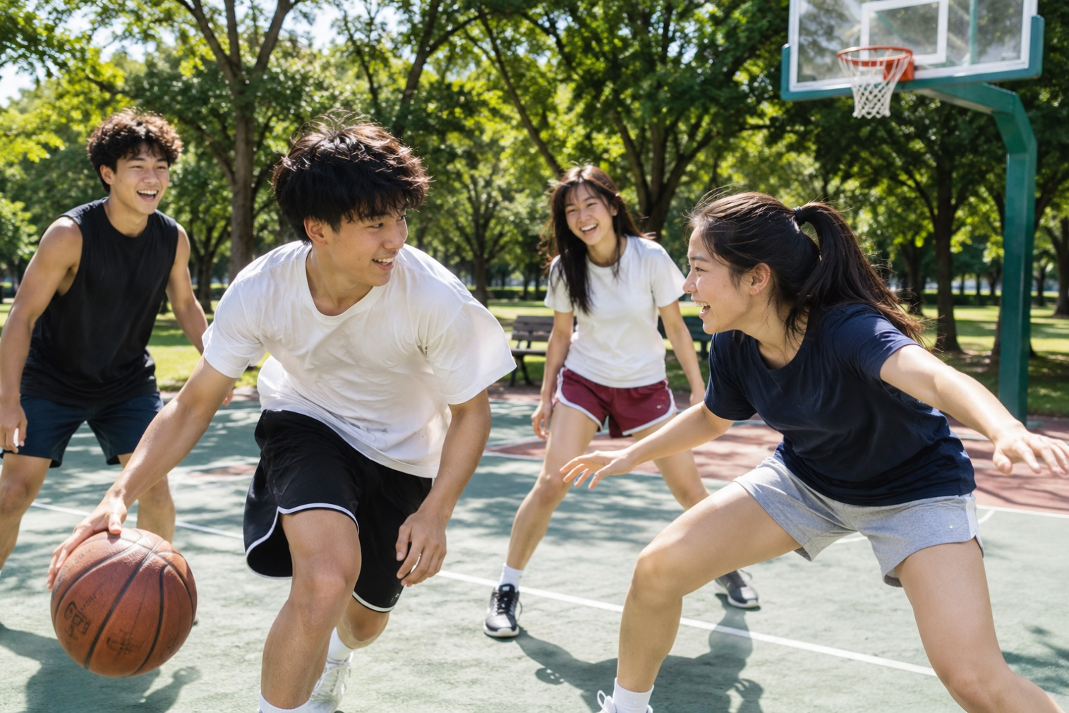

Q1 · Photo card
Question: 照片里有什么？ What is in the photo?
Model answer (Higher): 照片里有四个年轻人，两个男孩和两个女孩，他们在公园里打篮球。天气很好，是晴天。他们看起来很快乐，因为他们都在笑。我觉得打篮球对身体很好，我也喜欢和朋友一起做运动。
English: In the photo there are four young people, two boys and two girls, playing basketball in a park. The weather is nice; it is sunny. They look very happy, because they are all smiling. I think playing basketball is very good for you, and I also like doing sport with my friends.
Exam tip: Say who, where and what they are doing, then add the weather. Justify 看起来很快乐 with 因为 and something you can see, and finish with your own opinion (我觉得……).

Q2 · General conversation
Question: 你有空的时候喜欢做什么？ What do you like doing in your free time?
Model answer (Higher): 我有空的时候喜欢运动，特别是游泳和打羽毛球，因为运动对身体好。除了运动以外，我还喜欢弹吉他。我弹吉他弹得不错，我的朋友都说我弹得很好。
English: In my free time I like sport, especially swimming and badminton, because exercise is good for you. Apart from sport, I also like playing the guitar. I play the guitar quite well; my friends all say I play very well.
Exam tip: Complex structures: 除了……以外，还……, verb + 得 (弹吉他弹得不错), ……的时候.

Q3 · General conversation
Question: 你最近看了什么电影？ What film have you seen recently?
Model answer (Higher): 上个周末我和哥哥去电影院看了一个美国电影。虽然电影有点儿长，但是很有意思。看电影以后，我们去吃了比萨饼。我觉得在电影院看电影比在家看有意思。下个周末我们打算去看一个中国电影。
English: Last weekend my brother and I went to the cinema to see an American film. Although it was a bit long, it was very good. After the film we went for pizza. I think watching films at the cinema is more fun than at home. Next weekend we plan to see a Chinese film.
Exam tip: Complex structures: 虽然……但是……, A 比 B + adjective, ……以后. Time frames: past (看了, 吃了) and future (下个周末我们打算……).

Q4 · General conversation
Question: 你喜欢吃什么？你常常出去吃饭吗？ What do you like to eat? Do you often eat out?
Model answer (Higher): 我很喜欢吃中国菜，特别是北京烤鸭和饺子。我们家不常常去饭馆吃饭，因为太贵了，一般一个月去一次。上个星期六我们去吃了火锅，又好吃又便宜。下个月是我妈妈的生日，我们打算去一家有名的中国饭馆。
English: I love Chinese food, especially Peking duck and dumplings. My family doesn’t often eat out because it is too expensive; we usually go once a month. Last Saturday we had hotpot, which was both tasty and cheap. Next month is my mum’s birthday, and we plan to go to a famous Chinese restaurant.
Exam tip: Complex structures: 又……又……, 因为……. Frequency: 一个月去一次. Time frames: past (上个星期六我们去吃了火锅) and future (我们打算……).

Q5 · General conversation
Question: 你将来想学什么新爱好？ What new hobby would you like to take up in the future?
Model answer (Higher): 小时候我学过弹钢琴，可是我不太喜欢。将来我想学打太极拳，因为太极拳对身体好，也很有意思。如果以后有机会，我就去中国看京剧。
English: When I was little I learned the piano, but I didn’t really like it. In the future I want to learn tai chi, because it is good for you and very interesting. If I have the chance in the future, I will go to China to see Beijing opera.
Exam tip: Complex structures: verb + 过 (学过), 如果……就……. Time frames: past (小时候我学过……) and future (将来我想学……).

More general conversation questions
- 你喜欢听什么音乐？为什么？ What music do you like? Why?
- 你最喜欢的运动员是谁？为什么？ Who is your favourite sportsperson? Why?
- 你小时候喜欢做什么？现在呢？ What did you like doing when you were little? What about now?
- 上个周末你做了什么运动？ What sport did you do last weekend?
- 下个周末你想做什么？ What do you want to do next weekend?
- 如果你有很多钱，你想去看什么比赛？ If you had lots of money, what match would you like to go and see?
- 你的爱好是什么？你一般什么时候运动？ What are your hobbies? When do you usually do sport?

Need a tutor for GCSE Mandarin preparation or catching up? Visit: https://janesmandarintutor.co.uk/
Enquiries accepted from adult learners and parents only.

