Jane’s Mandarin Tutor Studio
GCSE Mandarin · Free resources
https://janesmandarintutor.co.uk/

Topic 5: Home, town, neighbourhood and region
Theme 2: Local, national, international and global areas of interest · Where you live and what it is like

Key vocabulary
Chinese | Pinyin | English
Rooms
房子 | fángzi | house
层 | céng | floor
楼上 | lóushàng | upstairs
楼下 | lóuxià | downstairs
门 | mén | door
客厅 | kètīng | living room
饭厅 | fàntīng | dining room
厨房 | chúfáng | kitchen
卧室 | wòshì | bedroom
书房 | shūfáng | study
浴室 | yùshì | bathroom
厕所 | cèsuǒ | toilet
花园 | huāyuán | garden
Furniture and things at home
桌子 | zhuōzi | table
椅子 | yǐzi | chair
把 | bǎ | measure word for chairs
床 | chuáng | bed
柜子 | guìzi | wardrobe
书架 | shūjià | bookcase
灯 | dēng | light
钟 | zhōng | clock
电视 | diànshì | TV
电话 | diànhuà | phone
电脑 | diànnǎo | computer
冰箱 | bīngxiāng | fridge
洗衣机 | xǐ yī jī | washing machine
炉子 | lúzi | cooker
空调 | kōngtiáo | air conditioning
Places in town
商店 | shāngdiàn | shop
超市 | chāoshì | supermarket
银行 | yínháng | bank
邮局 | yóujú | post office
电影院 | diànyǐngyuàn | cinema
公园 | gōngyuán | park
体育馆 | tǐyùguǎn | sports hall, stadium
运动中心 | yùn dòng zhōng xīn | sports centre
学校 | xuéxiào | school
美术馆 | měishùguǎn | art gallery
博物馆 | bówùguǎn | museum
展览馆 | zhǎnlǎnguǎn | exhibition hall
动物园 | dòngwùyuán | zoo
汽车站 | qìchēzhàn | bus station
火车站 | huǒ chē zhàn | train station
地铁站 | dì tiě zhàn | underground station
Where I live
地方 | dìfāng | place
住在 | zhùzài | live in/at
城市 | chéngshì | city
小镇 | xiǎozhèn | small town
郊区 | jiāoqū | suburb
农村 | nóngcūn | countryside
海边 | hǎibiān | seaside
山区 | shānqū | mountain area
树 | shù | tree
湖 | hú | lake
河 | hé | river
空气 | kōngqì | air
新鲜 | xīnxiān | fresh
安静 | ānjìng | quiet
热闹 | rènào | lively, bustling
吵 | chǎo | noisy
明信片 | míngxìnpiàn | postcard
Position
前边 | qiánbiān | front
后边 | hòubiān | back
左边 | zuǒbiān | left
右边 | yòubiān | right
Clothes
衣服 | yīfu | clothes
上衣 | shàngyī | top
衬衣 | chènyī | shirt
毛衣 | máoyī | jumper
夹克 / 大衣 | jiākè / dàyī | jacket/coat
裤子 | kùzi | trousers
裙子 | qúnzi | skirt, dress
领带 | lǐngdài | tie
皮带 | pídài | belt
袜子 | wàzi | socks
鞋 | xié | shoes
鞋子 | xiézi | shoes
运动鞋 | yùn dòng xié | trainers
帽子 | màozi | hat, cap
件 | jiàn | measure word for clothes
双 | shuāng | measure word for pairs
Colours
颜色 | yánsè | colour
黑 | hēi | black
白 | bái | white
红 | hóng | red
黄 | huáng | yellow
蓝 | lán | blue
绿 | lǜ | green
橙 | chéng | orange
紫 | zǐ | purple
粉红 | fěnhóng | pink
灰 | huī | grey
棕 | zōng | brown
浅 | qiǎn | light (colour); shallow
深 | shēn | dark (colour); deep
Shopping
买 | mǎi | to buy
卖 | mài | to sell
多少钱 | duō shǎo qián | how much?
太贵了 | tài guì le | too expensive
一共 | yīgòng | altogether

Grammar and complex structures for this topic
Use these in your speaking and writing. The full list is in the separate grammar document.
Structure | Meaning | Example for this topic
A 离 B 远 / 近 | A is far from / close to B | 我家离学校不远。  My home is not far from school.
又……又…… | both … and … | 我住的地方又安静又安全。  Where I live is both quiet and safe.
一方面……另一方面…… | on the one hand … on the other hand … | 一方面城市很方便，另一方面有点儿吵。  On the one hand the city is convenient; on the other hand it is a bit noisy.
A 比 B + adj + 多了 | A is much more … than B | 现在的房子比以前的大多了。  Our house now is much bigger than before.
A 没有 B 那么 + adj | A is not as … as B | 农村没有城市那么热闹。  The countryside is not as lively as the city.
与其……不如…… | rather than … it is better to … | 与其住在城市，不如住在海边。  Rather than living in the city, it’s better to live by the sea.

Speaking questions and model answers
Photo card: a photo of a busy city street.
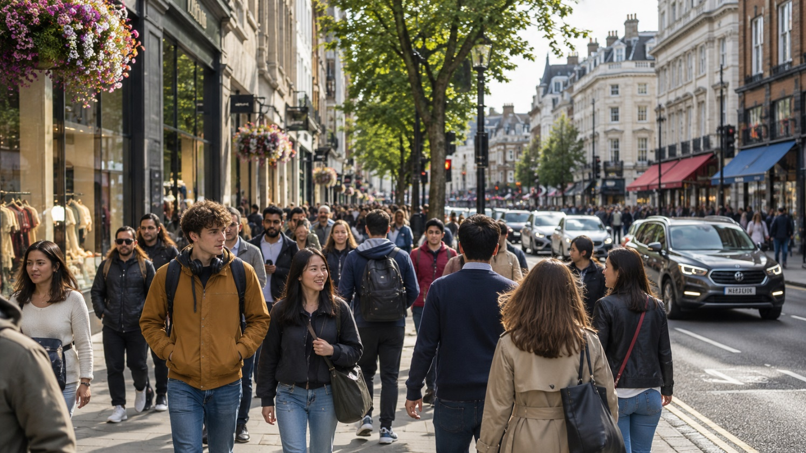

Q1 · Photo card
Question: 照片里有什么？ What is in the photo?
Model answer (Higher): 照片里有一条大街。大街上有很多人，也有很多汽车和商店。我觉得这里很热闹，因为人很多。
English: There is a street in the photo. There are lots of people in the street, and also lots of cars and shops. I think it is very lively here, because there are so many people.
Exam tip: Describe only what you can see: use the measure word 条 for 大街 (一条大街) and 也 to add more detail. Then give an opinion with a reason: 我觉得……，因为…….

Q2 · General conversation
Question: 你住在哪儿？你喜欢那儿吗？ Where do you live? Do you like it?
Model answer (Higher): 我住在英国南边的一个小镇，离伦敦不远。我很喜欢我住的地方，因为又安静又安全。我家附近有一个公园和一个超市，可是没有电影院。
English: I live in a small town in the south of England, not far from London. I really like where I live, because it is both quiet and safe. Near my home there is a park and a supermarket, but there isn’t a cinema.
Exam tip: Complex structures: A 离 B 不远, 又……又……, 有…… / 没有…….

Q3 · General conversation
Question: 请你介绍一下你的家。 Tell me about your home.
Model answer (Higher): 我家是一个两层的房子。楼下有客厅、饭厅和厨房，楼上有三个卧室和一个浴室。我最喜欢我的卧室，因为不但很安静，而且很漂亮，我可以在那儿看书、听音乐。我家后边还有一个小花园。
English: My home is a two-storey house. Downstairs there is a living room, a dining room and a kitchen; upstairs there are three bedrooms and a bathroom. My favourite room is my bedroom, because it is not only quiet but also beautiful, and I can read and listen to music there. There is also a small garden behind our house.
Exam tip: Complex structures: 不但……而且…… (不但很安静，而且很漂亮), 最喜欢……因为…… (an opinion with a reason). Use 楼上 / 楼下 and position words (后边) to organise your description.

Q4 · General conversation
Question: 你小时候住在哪儿？跟现在有什么不一样？ Where did you live as a child? How is it different now?
Model answer (Higher): 我小时候住在伦敦，那里不但很热闹，而且交通也很方便，可是我们的房子很小。五年前我们开始住在海边，现在的房子比以前的房子大多了，空气也很新鲜。将来我还是想住在海边。
English: When I was little I lived in London. It was not only lively, but transport was also convenient; however, our house was very small. Five years ago we started living by the sea; our house now is much bigger than our old house, and the air is fresh. In the future I still want to live by the sea.
Exam tip: Complex structures: 不但……而且…… (不但很热闹，而且交通也很方便), A 比 B + adjective + 多了 (现在的房子比以前的房子大多了 – “much bigger than”), ……，可是…… (contrast). Time frames: past (小时候……, 五年前……) and future (将来我还是想……).

Q5 · General conversation
Question: 将来你想住在哪儿？为什么？ Where would you like to live in the future? Why?
Model answer (Higher): 去年我去过上海，那里又大又热闹。将来我想住在大城市，因为城市里有很多工作机会，也有很多好玩儿的地方。不过我老了以后，可能会住在农村，因为农村不但很安静，而且空气也很新鲜。
English: Last year I went to Shanghai; it was big and lively. In the future I want to live in a big city, because there are lots of job opportunities and lots of fun places. But when I am old, I might live in the countryside, because the countryside is not only quiet, but the air is also fresh.
Exam tip: Complex structures: 又……又…… (又大又热闹), 不但……而且…… (不但很安静，而且空气也很新鲜), ……以后 (我老了以后). Time frames: past (去年我去过上海) and future (将来我想……, 可能会……).

More general conversation questions
- 你家附近有什么？ What is near your home?
- 你喜欢住在海边还是住在城市？为什么？ Do you prefer living by the sea or in a city? Why?
- 上个周末你在你住的地方做了什么？ What did you do where you live last weekend?
- 你以前去过哪个有意思的城市？ What interesting city have you been to before?
- 下个周末你打算在家附近做什么？ What do you plan to do near your home next weekend?
- 你觉得住在大城市有什么好处，有什么坏处？ What are the advantages and disadvantages of living in a big city?

Need a tutor for GCSE Mandarin preparation or catching up? Visit: https://janesmandarintutor.co.uk/
Enquiries accepted from adult learners and parents only.

