Jane’s Mandarin Tutor Studio
GCSE Mandarin · Free resources
https://janesmandarintutor.co.uk/

Topic 10: Life at school
Theme 3: Current and future study and employment · School day, rules, uniform and activities

Key vocabulary
Chinese | Pinyin | English
Places at school
教室 | jiàoshì | classroom
办公室 | bàngōng shì | office
校长办公室 | xiàozhǎng bàngōngshì | headteacher's office
礼堂 | lǐtáng | assembly hall
食堂 | shítáng | canteen, dining hall
操场 | cāochǎng | playground
体育馆 | tǐyùguǎn | sports hall, stadium
走廊 | zǒuláng | corridor
图书馆 | túshū guǎn | library
卫生间 / 厕所 / 洗手间 | wèishēngjiān / cèsuǒ / xǐshǒujiān | toilet
The school day
上学 | shàngxué | to go to school
放学 | fàngxué | to finish school
上课 | shàngkè | to have a lesson; lessons start
下课 | xiàkè | lessons end
休息 | xiūxi | break, to have a break
起床 | qǐchuáng | to get up
吃早饭 | chī zǎofàn | to eat breakfast
回家 | huíjiā | to go home
做作业 | zuò zuò yè | to do homework
Schools and people
小学 | xiǎoxué | primary school
中学 | zhōngxué | secondary school
校长 | xiàozhǎng | headteacher
老师 | lǎoshī | teacher
学生 | xuésheng | student
同学 | tóngxué | classmate
Uniform and equipment
校服 | xiàofú | uniform
书包 | shūbāo | school bag
笔 | bǐ | pen
毛笔 | máobǐ | brush pen
尺子 | chǐzi | ruler
橡皮 | xiàngpí | rubber
本子 | běnzi | exercise book
钟 | zhōng | clock
Rules and opinions
规则 / 规定 | guīzé / guīdìng | rules / regulations
必须 | bìxū | must, have to
不要 | búyào | must not
别 | bié | don't
公平 | gōngpíng | fair
同意 / 不同意 | tóngyì / bù tóngyì | agree/disagree
Activities and trips
夏令营 | xiàlìngyíng | summer camp
冬令营 | dōnglìngyíng | winter camp
留学体会 | liúxué tǐhuì | exchange visit
留学交流 | liúxué jiāoliú | study-abroad exchange
科技节 | kējì jié | science and technology festival
表演 | biǎoyǎn | to perform; performance
各种各样的 | gè zhǒng gè yàng de | all kinds of

Grammar and complex structures for this topic
Use these in your speaking and writing. The full list is in the separate grammar document.
Structure | Meaning | Example for this topic
必须 / 不要 / 别 | must / must not / don’t | 在我们学校，学生必须穿校服。  At our school, students must wear uniform.
除了……以外，还…… | apart from …, also … | 除了上课以外，我还参加课外活动。  Apart from lessons, I also take part in activities outside lessons.
……以后 | after … | 放学以后，我和同学一起踢足球。  After school I play football with my classmates.
一方面……另一方面…… | on the one hand … on the other hand … | 一方面穿校服很方便，另一方面不太舒服。  On the one hand uniform is convenient; on the other hand it isn’t very comfortable.
如果我是……，我就会…… | if I were …, I would … | 如果我是校长，我就会让午饭时间长一点儿。  If I were the headteacher, I would make lunchtime a bit longer.
总的来说 | overall, in summary | 总的来说，我很喜欢我的学校。  Overall, I really like my school.

Speaking questions and model answers
Photo card: a photo of students in school uniform in a playground.
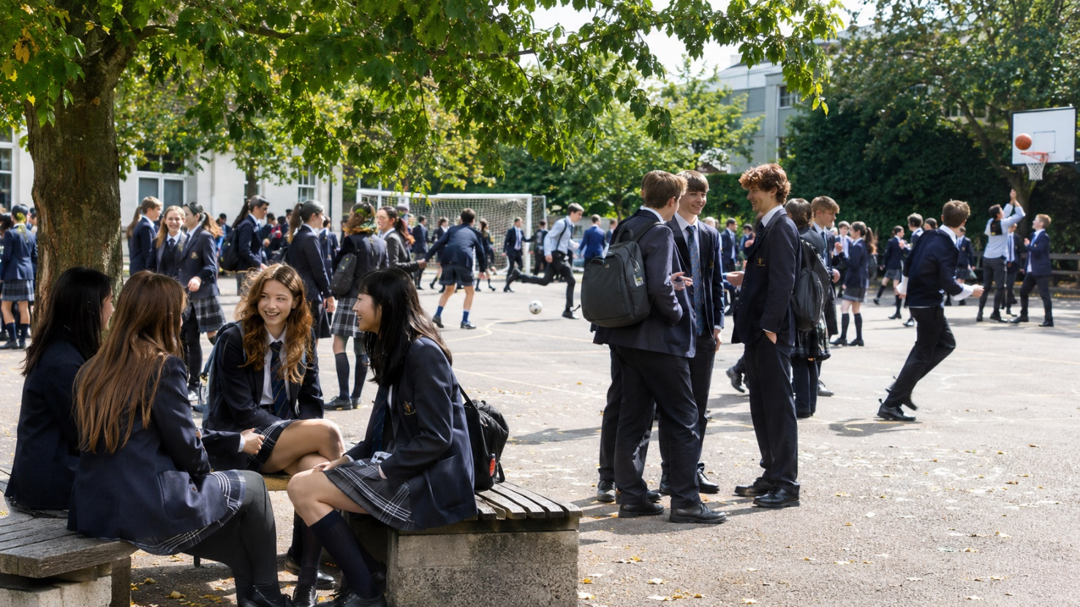

Q1 · Photo card
Question: 照片里有什么？ What is in the photo?
Model answer (Higher): 照片里有很多学生在操场上。他们都穿着校服，一些学生在聊天，一些学生在玩。我觉得现在是休息的时候，因为他们没有在教室里。
English: In the photo there are lots of students in the playground. They are all wearing school uniform; some students are chatting and some are playing. I think it is break time, because they aren’t in a classroom.
Exam tip: Describe only what you can see. Complex structures: 一些……一些…… (some … some …) to describe a group, verb + 着 (穿着) for what people are wearing, and 我觉得……，因为…… to give a reason for your guess.

Q2 · General conversation
Question: 请你介绍一下你的学校。 Tell me about your school.
Model answer (Higher): 我的学校是一个中学，有一千二百个学生。学校有很大的图书馆、食堂和体育馆。我最喜欢图书馆，因为那里不但很安静而且有很多书，我常常在那儿做作业。
English: My school is a secondary school with 1,200 students. It has a big library, a canteen and a sports hall. I like the library best, because it is not only quiet but also has lots of books, and I often do my homework there.
Exam tip: Complex structures: 最喜欢……因为……, 不但……而且…… (不但很安静而且有很多书). Use numbers with measure words (一千二百个学生).

Q3 · General conversation
Question: 你觉得你们学校的规则怎么样？ What do you think of your school rules?
Model answer (Higher): 我们学校的规则很多。比如，我们不但必须穿校服，而且上课的时候不要用手机。我同意这些规则，因为这些规则很公平。不过，我觉得冬天的时候学生应该可以穿自己的大衣。
English: Our school has lots of rules. For example, not only must we wear uniform, but we also mustn’t use phones in lessons. I agree with these rules, because they are fair. However, I think students should be allowed to wear their own coats in winter.
Exam tip: Complex structures: 比如 (for example), 不但……而且…… (不但必须穿校服，而且上课的时候不要用手机), ……的时候, 不过 (however) to give a different opinion. Vocabulary: 规则, 必须, 不要, 同意, 公平.

Q4 · General conversation
Question: 昨天在学校你做了什么？ What did you do at school yesterday?
Model answer (Higher): 昨天我上了五节课。第一节课是数学，我们有一个考试。午饭以后，我去参加了书法班。放学以后，我还和同学一起踢足球，六点才回家。明天我们要去参观博物馆。
English: Yesterday I had five lessons. The first lesson was maths, and we had a test. After lunch I went to calligraphy class. After school I played football with my classmates and didn’t get home until six. Tomorrow we are going to visit a museum.
Exam tip: Complex structures: ……以后, 才 (not until). Time frames: past (上了, 参加了) and future (明天我们要去……).

Q5 · General conversation
Question: 你觉得你的学校怎么样才能更好？ How could your school be better?
Model answer (Higher): 以前我们的午饭时间是一个小时，可是去年只有三十分钟了。如果我是校长，我就会让午饭时间长一点儿。我还想让学校有更多的课外活动，因为我很喜欢书法和国画。
English: Lunchtime used to be an hour, but last year it was cut to only thirty minutes. If I were the headteacher, I would make lunchtime a bit longer. I would also like the school to have more extracurricular activities, because I love calligraphy and Chinese painting.
Exam tip: Complex structures: 如果我是……，我就会……, 让 + noun + adjective. Time frames: past (以前……去年变成了……) and future / conditional (我会……).

More general conversation questions
- 中午休息的时候你做什么？ What do you do at lunch break?
- 你参加过什么课外活动？ What activities outside lessons have you done?
- 你喜欢你的小学还是中学？ Do you prefer your primary school or your secondary school?
- 中国学校和英国学校有什么不一样？ How are Chinese schools different from British schools?
- 你昨天参加了什么学校活动？ What school activities did you take part in yesterday?
- 明天放学以后你会做什么？ What will you do after school tomorrow?
- 下个学期你想参加什么活动？ What activity would you like to do next term?

Need a tutor for GCSE Mandarin preparation or catching up? Visit: https://janesmandarintutor.co.uk/
Enquiries accepted from adult learners and parents only.

