Jane’s Mandarin Tutor Studio
GCSE Mandarin · Free resources
https://janesmandarintutor.co.uk/

Topic 1: Me, my family and friends
Theme 1: Identity and culture · Relationships with family and friends; marriage and partnership

Key vocabulary
Chinese | Pinyin | English
Family members
家 | jiā | family
家人 | jiārén | family members
全家 | quánjiā | whole family
爸爸 | bàba | dad
父亲 | fùqīn | father
妈妈 | māma | mum
母亲 | mǔqīn | mother
哥哥 | gēge | older brother
姐姐 | jiějie | older sister
弟弟 | dìdi | younger brother
妹妹 | mèimei | younger sister
爷爷 | yéye | grandfather
奶奶 | nǎinai | grandmother
孙子 | sūnzi | grandson
孙女 | sūnnǚ | granddaughter
儿子 | érzi | son
女儿 | nǚ’ér | daughter
叔叔 | shūshu | uncle
阿姨 | āyí | aunt
亲戚 | qīnqi | relatives
孩子 | háizi | child
男孩 | nánhái | boy
女孩 | nǚhái | girl
独生子 | dúshēngzǐ | only child
成人 | chéngrén | adult, grown-up
先生 | xiānsheng | Mr.; husband
太太 | tàitai | Mrs.; wife
Personal details
名字 | míngzi | name
年纪 | niánjì | age
岁 | suì | years old
生日 | shēngrì | birthday
电话号码 | diànhuà hàomǎ | telephone number
地址 | dìzhǐ | address
护照 | hùzhào | passport
身份证 | shēnfènzhèng | identity card
出生日期 | chūshēng rìqī | date of birth
出生地点 | chūshēng dìdiǎn | place of birth
性别 | xìngbié | gender
Pronouns
我 | wǒ | I, me
你 | nǐ | you
他 | tā | he, him
她 | tā | she, her
它 | tā | it
我们 | wǒmen | we, us
你们 | nǐmen | you (plural)
他们 | tāmen | they
我的 | wǒ de | my, mine
你的 | nǐ de | your
他的 | tā de | his
她的 | tā de | her, hers
它的 | tā de | its
我们的 | wǒmen de | our, ours
你们的 | nǐmen de | your, yours
他们的 | tāmen de | their, theirs
Appearance and the body
高 | gāo | tall; high
矮 | ǎi | short
胖 | pàng | fat
瘦 | shòu | thin
长 | cháng | long
短 | duǎn | short
好看 | hǎokàn | good looking
漂亮 | piàoliang | pretty, beautiful
美丽 | měilì | beautiful
帅 | shuài | handsome, smart
头 | tóu | head
头发 | tóufa | hair
脸 | liǎn | face
眼睛 | yǎnjīng | eyes
鼻子 | bízi | nose
嘴 | zuǐ | mouth
耳朵 | ěrduo | ear
牙 | yá | tooth
手 | shǒu | hand
手臂 | shǒubì | arm
肚子 | dùzi | stomach, tummy
背 | bèi | back
腿 | tuǐ | leg
脚 | jiǎo | foot
Personality
聪明 | cōngming | clever
友好 | yǒuhǎo | friendly
安静 | ānjìng | quiet
亲切 | qīnqiè | kind, warm
幽默 | yōumò | humorous
有趣 | yǒuqù | interesting, amusing
好玩儿 | hǎowánr | fun
可爱 | kěài | cute, lovable
酷 | kù | cool
快乐 | kuàilè | happy
严肃 | yánsù | serious
严格 | yángé | strict
有礼貌 | yǒu lǐmào | polite
懒 | lǎn | lazy
笨 | bèn | stupid, slow
生气 | shēngqì | angry
Pets
宠物 | chǒngwù | pet
猫 | māo | cat
狗 | gǒu | dog
马 | mǎ | horse
兔子 | tùzi | rabbit
鸟 | niǎo | bird
鱼 | yú | fish
蛇 | shé | snake
只 | zhī | measure word for animals and birds
条 | tiáo | measure word for long, thin things (fish, snakes, trousers)
Friends and relationships
朋友 | péngyou | friend
笔友 | bǐyǒu | penfriend
男朋友 | nánpéngyou | boyfriend
女朋友 | nǚpéngyou | girlfriend
客人 | kèren | guest
结婚 | jiéhūn | to get married; married
未婚 | wèihūn | unmarried
离婚 | líhūn | divorced
婚礼 | hūnlǐ | wedding
Likes and dislikes
我很喜欢 | wǒ hěn xǐhuan | I like… (very much)
我很讨厌 | wǒ hěn tǎoyàn | I can’t stand…/I don’t like

Grammar and complex structures for this topic
Use these in your speaking and writing. The full list is in the separate grammar document.
Structure | Meaning | Example for this topic
又……又…… | both … and … | 我妈妈又幽默又漂亮。  My mum is both funny and pretty.
不但……而且…… | not only … but also … | 我爸爸不但很聪明，而且很亲切。  My dad is not only clever but also kind.
A 比 B + adj + 一点儿 | A is a bit more … than B | 我哥哥比我高一点儿。  My older brother is a bit taller than me.
A 跟 B 一样 | A is the same as B | 我跟我妹妹一样喜欢猫。  Like my younger sister, I love cats.
是……的 | stresses when / where / how a past action happened | 我们是在小学认识的。  We met at primary school.
……的时候 | when … | 我有问题的时候，我妈妈总是帮助我。  When I have a problem, my mum always helps me.
依我来看 | as far as I’m concerned | 依我来看，好朋友应该帮助我。  As far as I’m concerned, a good friend should help me.
如果……就…… | if … then … | 如果我结婚，我就要两个孩子。  If I get married, I would like to have two children.

Speaking questions and model answers
Photo card: a photo of five people eating together at a table.
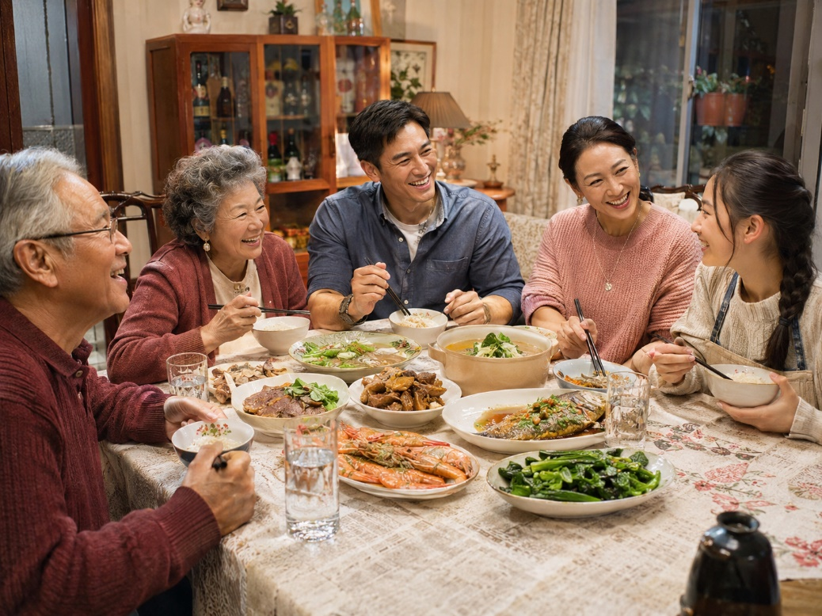

Q1 · Photo card
Question: 照片里有什么？ What is in the photo?
Model answer (Higher): 照片里有五个人：两个男人，两个女人和一个女孩。他们正在一起吃饭，桌子上有很多菜。看起来他们的关系很好，因为他们一边吃饭一边聊天，而且都在笑。
English: In the photo there are five people: two men, two women and a girl. They are eating together and there are lots of dishes on the table. Their relationship looks good, because they are chatting while they eat, and they are all laughing.
Exam tip: Describe who, where and what they are doing, but don’t assume their relationship, then add an opinion. 一边……一边…… and 看起来 (it looks as if) lift a simple description, but you must justify it with a reason starting with 因为. Don’t write about things you can’t see in the photo.

Q2 · General conversation
Question: 你和家人的关系怎么样？ How do you get on with your family?
Model answer (Higher): 总的来说，我跟家人的关系很好。我妈妈又幽默又漂亮，我有问题的时候，她总是帮助我。我爸爸不但很聪明，而且很亲切，我们喜欢一起看电影。我爱我的家人。
English: Overall, I have a good relationship with my family. My mum is both funny and pretty, and she always helps me when I have a problem. My dad is not only clever but also kind, and we like watching films together. I love my family.
Exam tip: Complex structures: 又……又……, 不但……而且……, ……的时候. Start with 总的来说 (overall) to sound fluent.

Q3 · General conversation
Question: 上个周末你和家人做了什么？ What did you do with your family last weekend?
Model answer (Higher): 因为上个周末是我爷爷的生日，所以我和家人一起去了一个中国饭馆。我们不但吃了饺子和面条，而且还给爷爷买了礼物。那天我非常快乐，因为我们全家都喜欢中国菜。下个周末我们打算一起去海边玩。
English: Because last weekend was my grandad’s birthday, my family and I went to a Chinese restaurant together. We not only ate dumplings and noodles but also bought Grandad presents. I was very happy that day, because our whole family loves Chinese food. Next weekend we plan to go to the seaside together.
Exam tip: Complex structures: 因为……所以……, 不但……而且……. Time frames: past with 了 (去了, 吃了, 买了) and future with 打算 (下个周末我们打算……).

Q4 · General conversation
Question: 你将来想结婚吗？为什么？ Would you like to get married in the future? Why?
Model answer (Higher): 我将来想结婚，因为我想有自己的家。我爸爸妈妈是在大学认识的，他们结婚二十年了。他们不但常常一起做饭，而且常常一起去旅行，所以我觉得结婚很好。如果我结婚，我就要两个孩子。
English: I would like to get married in the future because I want my own family. My parents met at university and have been married for twenty years. They not only often cook together but also often travel together, so I think marriage is good. If I get married, I would like to have two children.
Exam tip: Complex structures: 是……的 (是在大学认识的), 不但……而且……, 如果……就……. Time frames: past (是在大学认识的, 结婚二十年了) and future (我将来想结婚).

Q5 · General conversation
Question: 你觉得好朋友应该是什么样的？ What do you think a good friend should be like?
Model answer (Higher): 依我来看，好朋友应该很友好，也应该帮助我。我最好的朋友叫Amy，我们是在小学认识的。她又聪明又幽默。上个星期我生病了，她不但给我打电话，而且还帮我买东西。我们下个周末想一起去电影院看电影。
English: As far as I’m concerned, a good friend should be friendly and should help me. My best friend is called Amy; we met at primary school. She is both clever and funny. Last week I was ill, and she not only phoned me but also did some shopping for me. Next weekend we want to go to the cinema together to watch a film.
Exam tip: Complex structures: 是……的, 又……又……, 不但……而且……. Opinion phrase: 依我来看. Time frames: past (上个星期我生病了) and future (我们下个周末想……).

More general conversation questions
- 你家有几口人？他们的爱好是什么？ How many people are there in your family? What are their hobbies?
- 你有宠物吗？它叫什么名字？ Do you have a pet? What is it called?
- 你喜欢跟家人还是跟朋友一起去度假？为什么？ Do you prefer going on holiday with your family or your friends? Why?
- 你上个假期和家人/朋友一起去了哪儿？ Where did you go with your family / friends on your last holiday?
- 你下个周末想和家人/朋友去做什么？ What do you want to do with your family / friends next weekend?
- 你觉得做独生子好还是有兄弟姐妹好？ Do you think it is better to be an only child or to have brothers and sisters?

Need a tutor for GCSE Mandarin preparation or catching up? Visit: https://janesmandarintutor.co.uk/
Enquiries accepted from adult learners and parents only.

