Jane’s Mandarin Tutor Studio
GCSE Mandarin · Free resources
https://janesmandarintutor.co.uk/

Topic 9: My studies
Theme 3: Current and future study and employment · School subjects and opinions

Key vocabulary
Chinese | Pinyin | English
School subjects
科目 | kēmù | subject
英文 | yīngwén | English
英语 | yīngyǔ | English
汉语 | hànyǔ | Chinese (Mandarin)
中文 | zhōngwén | Chinese
法文 | fǎwén | French
德文 | déwén | German
意大利文 | yìdàlì wén | Italian
西班牙文 | Xībānyáwén | Spanish (language)
数学 | shùxué | maths
科学 | kēxué | science
物理 | wùlǐ | physics
化学 | huàxué | chemistry
生物 | shēngwù | biology
历史 | lìshǐ | history
地理 | dìlǐ | geography
美术 | měishù | art
音乐 | yīnyuè | music
体育 | tǐyù | PE
电脑 | diànnǎo | computer
手工 | shǒugōng | DT
戏剧 | xìjù | drama
经济 | jīngjì | economics
书法 | shūfǎ | calligraphy
国画 | guóhuà | traditional Chinese painting
Learning
老师 | lǎoshī | teacher
学生 | xuésheng | student
男学生 | nán xuésheng | male student
女学生 | nǚ xuésheng | female student
同学 | tóngxué | classmate
班 | bān | class
课 | kè | lesson
节 | jié | measure word for lesson
作业 | zuòyè | homework
做作业 | zuò zuò yè | to do homework
考试 | kǎoshì | exam
教 | jiāo | to teach
学 | xué | to learn/to study
练习 | liànxí | to practise; exercise
汉字 | hànzì | Chinese character(s)
得到好成绩 | dédào hǎo chéngjì | achieve good results
Opinions about subjects
有意思 | yǒu yì si | interesting
没意思 | méi yì si | boring
有趣 | yǒuqù | interesting, amusing
容易 | róngyì | easy
难 | nán | difficult
聪明 | cōngming | clever
Exams and success
压力 | yālì | pressure
庆祝 | qìngzhù | to celebrate
成功 | chénggōng | to succeed
中学会考 | zhōngxué huìkǎo | secondary school exams (like GCSEs)
高考 | gāokǎo | university entrance exam (in China)
第一名 | dì-yī míng | first place

Grammar and complex structures for this topic
Use these in your speaking and writing. The full list is in the separate grammar document.
Structure | Meaning | Example for this topic
越……越…… | the more … the more … | 我越学越喜欢中文。  The more I learn, the more I like Chinese.
A 比 B + adj | A is more … than B | 数学比历史难。  Maths is harder than history.
对……有兴趣 | to be interested in … | 我对科学很有兴趣。  I am very interested in science.
为了…… | in order to … | 为了得到好成绩，我每天练习写汉字。  To get good results, I practise writing characters every day.
我以前觉得……，但是现在…… | I used to think …, but now … | 我以前觉得数学很难，但是现在觉得很有意思。  I used to think maths was hard, but now I find it interesting.
除了……以外，还…… | apart from …, also … | 除了中文以外，我还学法文。  Apart from Chinese, I also study French.

Speaking questions and model answers
Photo card: a photo of a classroom with some students and a teacher.
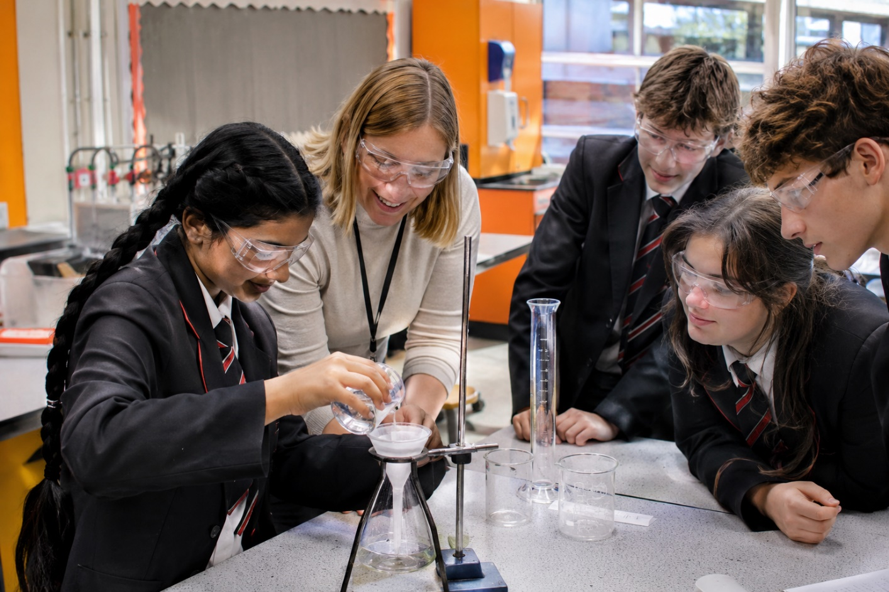

Q1 · Photo card
Question: 照片里有什么？ What is in the photo?
Model answer (Higher): 照片里有一个教室，有几个学生和一个老师。老师在帮助一个学生。学生们看起来很忙，因为他们都在看桌子上的东西。
English: The photo shows a classroom with some students and a teacher. The teacher is helping a student. The students look busy, because they are all looking at the things on the table.
Exam tip: Describe only what you can see. Complex structures: 在 + verb (老师在帮助一个学生), 看起来…… (学生们看起来很忙), and ……，因为…… with something you can see (他们都在看桌子上的东西).

Q2 · General conversation
Question: 你最喜欢什么科目？为什么？ What is your favourite subject? Why?
Model answer (Higher): 我最喜欢的科目是历史，因为历史很有意思，我们的历史老师又幽默又亲切。我不太喜欢数学，因为数学比历史难多了。除了历史以外，我还喜欢中文，因为汉字很漂亮。
English: My favourite subject is history, because it is interesting and our history teacher is both funny and kind. I don’t really like maths, because it is much harder than history. Apart from history, I also like Chinese, because Chinese characters are beautiful.
Exam tip: Complex structures: 最喜欢的……是……, 又……又…… (又幽默又亲切), A 比 B + adjective + 多了 (数学比历史难多了 – “much harder than”), 除了……以外，还…… (除了历史以外，我还喜欢中文).

Q3 · General conversation
Question: 你觉得哪个科目最难？ Which subject do you find hardest?
Model answer (Higher): 我觉得物理最难，因为要学很多东西。因为上次考试我的物理不太好，所以现在我每个星期多练习一个小时。下次考试我希望能得到好成绩。
English: I think physics is the hardest, because there is a lot to learn. Because my physics result in the last exam wasn’t very good, I now practise for an extra hour every week. In the next exam I hope to get good results.
Exam tip: Complex structures: 因为……，所以…… (因为上次考试我的物理不太好，所以……), 希望能 + verb (希望能得到好成绩). Time frames: past (上次考试……) and future (下次考试我希望……). Vocabulary: 得到好成绩.

Q4 · General conversation
Question: 你学中文学了多久了？为什么学中文？ How long have you been learning Chinese? Why?
Model answer (Higher): 我从七年级开始学中文，已经学了四年了。我学中文是因为我想去中国旅行，而且中文又有用又有意思。虽然汉字很难写，但是我越来越喜欢。将来我想用中文和中国人聊天。
English: I started learning Chinese in Year 7, so I have been learning it for four years. I learn Chinese because I want to travel to China, and Chinese is both useful and interesting. Although characters are hard to write, I like it more and more. In the future I want to chat with Chinese people in Chinese.
Exam tip: Complex structures: 从……开始 + 已经……了 (从七年级开始学中文，已经学了四年了), 是因为……, 又……又…… (又有用又有意思), 虽然……但是……, 越来越 + verb (越来越喜欢). Time frames: past (从七年级开始……学了四年了) and future (将来我想……).

Q5 · General conversation
Question: 明年你打算学什么科目？ What subjects are you planning to study next year?
Model answer (Higher): 明年我打算学数学、化学和中文，因为我将来想做医生。去年我参加了学校的科学比赛，还得了第一名，所以我对科学很有兴趣。我知道明年会很忙，但是我会努力学习。
English: Next year I plan to study maths, chemistry and Chinese, because I want to be a doctor. Last year I took part in the school science competition and came first, so I am very interested in science. I know next year will be busy, but I will study hard.
Exam tip: Complex structures: ……，所以…… (所以我对科学很有兴趣), 对……有兴趣, ……，但是…… (contrast). Time frames: past (去年我参加了……) and future (明年我打算……).

More general conversation questions
- 你学了什么语言？为什么学语言？ What languages have you learned? Why do you learn languages?
- 你觉得什么样的老师是好老师？ What kind of teacher do you think is a good teacher?
- 你上次考试考得怎么样？ How did you do in your last exam?
- 小学的时候，你最喜欢什么课？现在呢？ What was your favourite lesson at primary school? What about now?
- 你喜欢你的学校吗？为什么？ Do you like your school? Why?
- GCSE考试以后，你会怎么庆祝？ How will you celebrate after your GCSE exams?
- 你将来想用中文做什么？ What would you like to do with Chinese in the future?
- 将来你想上大学吗？为什么？ Would you like to go to university in the future? Why?

Need a tutor for GCSE Mandarin preparation or catching up? Visit: https://janesmandarintutor.co.uk/
Enquiries accepted from adult learners and parents only.

